Exercise 11 – Sudoku

Difficulty level: 4 out of 5

Write a program that can solve a medium-level difficulty Sudoku puzzle.

Please search online for playing instructions if you don’t know how to play the game.

Medium-level difficulty means that if you did it manually, you would use pencil marks for each empty box to write down possible number choices. But, there should be at least one box in the puzzle at any given time that gives you only one number left to choose from. This means that you won’t have to make a choice that may possibly not work and backtrack to find the right answer.

Uncle Edward will have sample Sudoku puzzles that he will use to test your program that will meet the above medium-level criteria.

Basically, for your program, here’s the flow:

1) User enters the numbers that have already been given in the Sudoku puzzle problem.

2) Program outputs a finished Sudoku puzzle with all the numbers filled in.

You have two options, you can:

1) Use javascript to make a nice user interface for the Sudoku game.

2) Just use Eclipse and not have a nice user interface.

This is an example for Option 2. If this is your Sukodu problem:

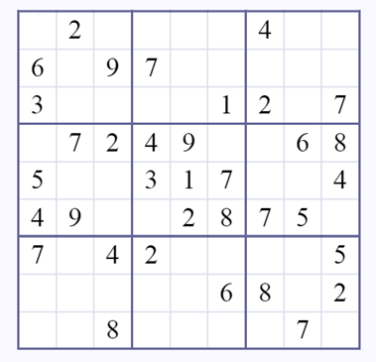

You have two sub-options. The first sub-option is that you can have the user input something like this:

020000400

609700000

300001207

072490068

500317004

490028750

704200005

000006802

008000070

For the spaces, you can have the user enter 0’s.

The second sub-option is that you can have your program read a file that contains the green numbers shown above.

So the answer and the output will be:

827953416

619742583

345861297

172495368

586317924

493628751

764289135

931576842

258134679

Or you can make it a tad bit nicer by making look like a table of some sort by adding spacing and lines.